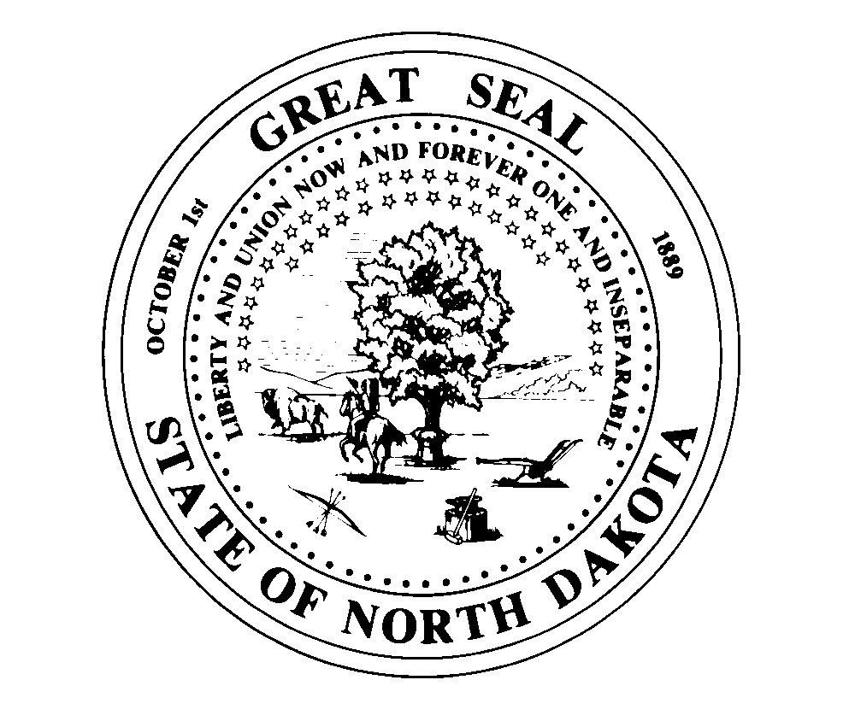
OFFICE OF THE EXECUTIVE DIRECTOR 1838 E Interstate Ave Suite D
Bismarck ND 58503
Telephone (701] 877- 2404
Fax (701] 877-2405
STATE BOARD OF PHARMACY
State of North Dakota E-mail= Mhardy@ndboard.pharmacy
Doug Burgum, Governor www.ndboard.pharmacy
Mark J. Hardy, PharmD
Executive Director
June 7, 2023

NDCC 28-32-08.1 – Small Entity Economic Impact and Regulatory Statement to amend rules in NDAC 61

61-01-01 Organization of Board-Revising the Board’s stated purpose and contact information

61-02-01-03 Pharmaceutical compounding standards-Update to adopt revised United States Pharmacopeia 795 & 797 chapters.

61-02-07.1 Pharmacy Technician-revisions to tech-check-tech, posting of registration and reinstatement process for technicians.

61-03-01 Licensure of Pharmacists-Create Canadian license transfer process and posting of registration.

61-04-10 CLIA Waived Laboratory Tests-Allow delegation to Registered Pharmacy Technicians

61-04-12 Limited Prescriptive Authority for Naloxone-Make section product agnostic for other opioid reversal agents.

Although the Board of Pharmacy, as a professional or regulatory Licensing Board authority is exempt from the sections on Small Entity Economic Impact and Regulatory Analysis, I believe it is prudent to describe some potential impacts, so the regulated parties will understand the implications of the rules identified above.

The Board of Pharmacy does not believe there will be any significant negative financial impact on small entities with these rule changes. Most of the proposed rules will ease regulatory conditions for pharmacies to operate within.

The updates to the USP chapters 795 and 797 will require some modifications to processes in locations which prepare compounded products. Generally, the changes will not limit products prepared, however there may be updated beyond use dating that may be limiting their use.

Revisions to the Technician check Technician process is based on feedback from the regulated community on their desire to utilize technicians in training in the long establish process. Removing the need to post registration is intended to ease a regulatory burden given those registrations are easily verified on the Board’s website for the public or the profession. Lastly, the capping of fees for reinstatement is intended to limit the financial barrier for reentry to the profession for individuals.

The streamlined process for Canadian pharmacists to get licensed in North Dakota may provide an opportunity for some pharmacies to address workforce demands. There will be similar safeguards in the licensure process to assure competency and fitness to practice compared to pharmacists coming from other states. Removing the need to post licenses is intended to ease a regulatory burden given those licenses are easily verified on the Board’s website for the public or the profession.

Providing professional discretion for pharmacists to utilize properly educated registered pharmacy technicians in the CLIA waived testing process was requested by the regulated community. The profession’s incorporation of CLIA waived tests into practices provides a meaningful resource to patients in North Dakota. Having the ability to delegate certain aspects of the testing process will allow for streamlined models to free up the pharmacist’s time to better interact with patients in each care setting.

The goal of the prescriptive authority for opioid reversal agents by pharmacists has been instrumental in North Dakota’s approach to the opioid epidemic. Given the new opioid reversal agents that will be coming to market, the request was made by industry to make the rule product agnostic.

Mark J. Hardy, PharmD
Executive Director

