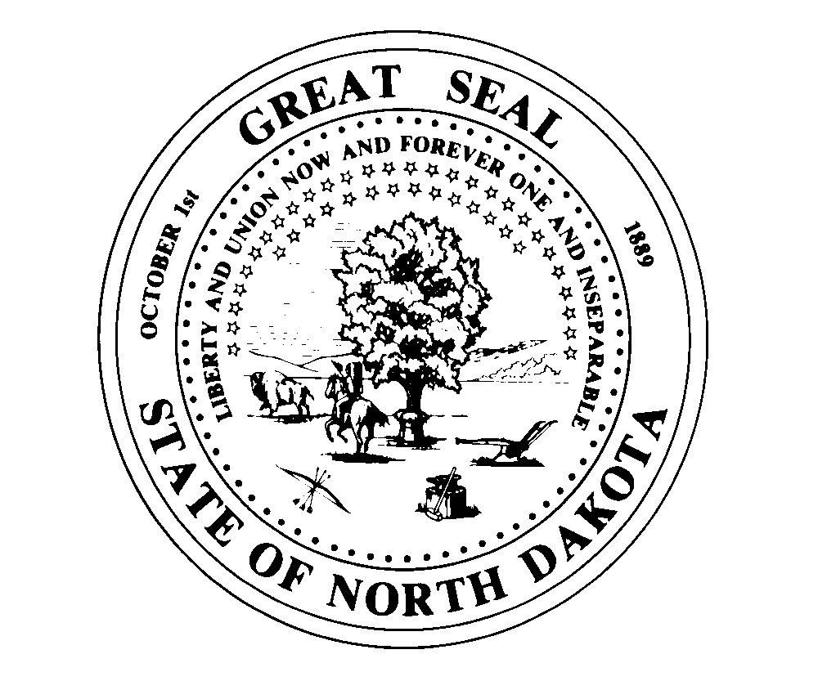
OFFICE OF THE EXECUTIVE DIRECTOR 1838 E Interstate Ave Suite D
Bismarck ND 58503
Telephone (701] 877- 2404
Fax (701] 877-2405
STATE BOARD OF PHARMACY
State of North Dakota E-mail= Mhardy@ndboard.pharmacy
Doug Burgum, Governor www.ndboard.pharmacy
Mark J. Hardy, PharmD
Executive Director
June 7, 2023

NDCC 28-32-08 – Regulatory Analysis relative to amendments of
rules in NDAC 61

61-01-01 Organization of Board - Revising the Board’s stated purpose and contact information

61-02-01-03 Pharmaceutical compounding standards - Update to adopt revised United States Pharmacopeia 795 & 797 chapters.

61-02-07.1 Pharmacy Technician - Revisions to tech-check-tech, posting of registration and reinstatement process for technicians.

61-03-01 Licensure of Pharmacists - Create Canadian license transfer process and posting of registration.

61-04-10 CLIA Waived Laboratory Tests - Allow delegation to Registered Pharmacy Technicians

61-04-12 Limited Prescriptive Authority for Naloxone - Make section product agnostic for other opioid reversal agents.

Neither the Governor, nor a member of the Legislative Assembly has filed a written request for a Regulatory Analysis for these rules. The Board does want to provide some context to the proposed amendments.

The proposed rules are not expected to have an impact on the regulatory community as a whole in excess of $50,000. The regulated community consists of pharmacies, pharmacists, interns and pharmacy technicians engaged in the practice of Pharmacy in the State. These rules are intended to change the Administrative Code to address changes requested by the regulated community, create opportunities for pharmacist services, and create efficiencies in licensure requirements.

Many of the proposed rules and amendments will affect pharmacists and pharmacy technicians in a positive way to allow them to expand in the professional practice outlined in the rules. The proposed rule on Canadian licensure transfer is meant to streamline licensure for Canadian pharmacist that may want to practice in North Dakota to help with workforce needs.

The Board of Pharmacy will be minimally impacted We anticipate the cost of each rule to be minimal and will not have any effect on State Revenue or licensure fees collected by the State Board of Pharmacy.

Mark J. Hardy, PharmD
Executive Director

