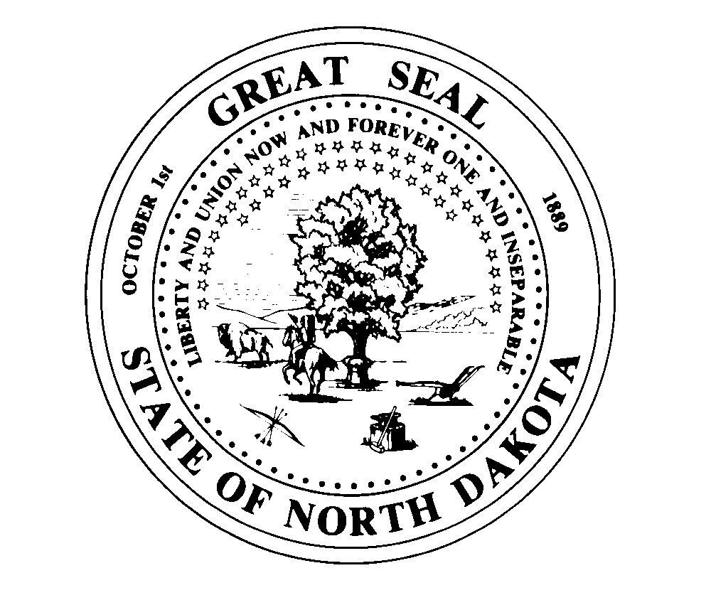
OFFICE OF THE EXECUTIVE DIRECTOR 1838 E Interstate Ave Suite D
Bismarck ND 58503
Telephone (701] 877- 2404
Fax (701] 877-2405
STATE BOARD OF PHARMACY
State of North Dakota E-mail= Mhardy@ndboard.pharmacy Doug Burgum, Governor www.ndboard.pharmacy
Mark J. Hardy, PharmD
Executive Director

June 7, 2023

NDCC 28-32-08.2 – Fiscal Note Pertaining to amendments of rules in NDAC 61

61-01-01 Organization of Board-Revising the Board’s stated purpose and contact information

61-02-01-03 Pharmaceutical compounding standards-Update to adopt revised United States Pharmacopeia 795 & 797 chapters.

61-02-07.1 Pharmacy Technician-revisions to tech-check-tech, posting of registration and reinstatement process for technicians.

61-03-01 Licensure of Pharmacists-Create Canadian license transfer process and posting of registration.

61-04-10 CLIA Waived Laboratory Tests-Allow delegation to Registered Pharmacy Technicians

61-04-12 Limited Prescriptive Authority for Naloxone-Make section product agnostic for other opioid reversal agents.

The Board of Pharmacy does not expect any fiscal impact on the operations of the Board in the adoption of these rules.

Compliance with proposed rules will be determined based on the regular annual Inspection that is provided to pharmacies.

Mark J. Hardy, PharmD
Executive Director

